**DOCUMENT OBJECT**

* The document object represents the whole html document which is loaded in the browser. It is the root element that represents the html document.
* By accessing the document object, we access the element in the HTML page.
* It has properties and methods. With the help of document objects, we can add dynamic content to our web page.
* The document object can be accessed with a **window.document** or just **document.**

**SYNTAX:**

**document.property_name;**

**PROPERTIES OF DOCUMENT OBJECT:**

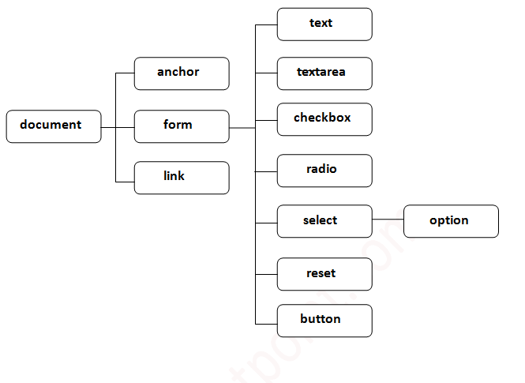

**METHODS OF DOCUMENT OBJECT**:

We can access and change the contents of document by its methods.

The important methods of document object are as follows:

|  |  |
| --- | --- |
| **Method** | **Description** |
| write("string") | Write the given string on the document. |
| writeln("string") | Write the given string on the document with newline character at the end. |
| getElementById() | Returns the element having the given id value. |
| getElementByName() | Returns all the elements having the given name value. |
| getElementsByTagName() | Returns all the elements having the given tag name. |
| getElementsByClassName() | Returns all the elements having the given class name. |

**WINDOW OBJECT**

The window object represents a window in browser. An object of window is created automatically by the browser.

The window object is the topmost object of the DOM hierarchy.

It represents a browser window or frame that displays the contents of the webpage. Whenever a window appears on the screen to display the contents of the document, the window object is created.

Window is the object of browser; it is not the object of java script. The JavaScript objects are string, array, date etc.

**SYNTAX:**

**window.property_name;**

**PROPERTIES OF WINDOW OBJECT:**

**1. alert( )**

It displays the alert box containing message with OK button.

**2. confirm( )**

It displays the confirm dialog box containing message with ok and cancel button.

**3. prompt( )**

It displays a dialog box to get input from the user.

**4. open( )**

It opens the new window.

**5. close( )**

It closes the current window.

**6. setTimeout( )**

It performs action after specified time like calling function, evaluating expressions etc.

|  |  |
| --- | --- |
| **DOCUMENT** | **OBJECT** |
| It represents any HTML document or web page that is loaded in the browser. | It represents a browser window or frame that displays the contents of the webpage. |
| It is loaded inside the window | It is the very first object that is loaded in the browser. |
| It is the object of window property. | It is the object of the browser. |
| All the tags, elements with attributes in HTML are part of the document. | Global objects, functions, and variables of JavaScript are members of the window object. |
| We can access the document from a window using the window. document | We can access the window from the window only. i.e. window.window |
| The document is part of BOM (browser object model) and DOM (Document object model) | The window is part of BOM, not DOM. |
| Properties of document objects such as title, body, cookies etc., can also be accessed by a window like this window. document.title | Properties of the window object cannot be accessed by the document object. |
| SYNTAX:  document.property_name | SYNTAX:  window.property_name |
| Example:       document.title :  will return the title of the document | Example:  window.innerHeight : will return the height of the content area of the browser |